National Association of Community Development Extension Professionals
Annual Business Meeting
June 11, 2018
Cleveland, Ohio
Minutes

Call to Order: Trudy Rice called the meeting to order at 12:49 pm eastern time.
President Trudy Rice opened the meeting by thanking Ohio State for hosting the 2018 conference. Trudy challenged us all to take advantage of this opportunity to increase our knowledge and build new friendships.

Approval of the Agenda for the 2018 NACDEP Annual Business Meeting: Mary Peabody, moved to approve the agenda. Susan Kelly seconded the motion. Motion passed.
JCEP Presentation Michael Lambur
We are all JCEP members.
2019 Extension Leadership Conference sponsored by JCEP, February 6-7, 2019 in San Antonio, TX
2019 PILD Conference, April 14-17, 2019 in Crystal City, VA
Why JCEP?
- Advocate for Extension
- Encourage Scholarship
- Foster Collaboration
- Create Synergy
What JCEP Does?
- Advances Partnerships
- Strengthens Extension
- Promotes Unity
JCEP Benefits
- Professional Development (JCEP will be posting webinars for all 7 associations.)
- Recognition
- Engagement

Bob Ohlensehlen
JCEP Executive Director
Phone: 208-736-4495
Email: jcepoffice@jcep.org

Secretary’s Report
NACDEP 2018 Secretary, Suzette Barta presented the minutes from the 2017 Annual Meeting in Big Sky, Montana and noted a discrepancy in the start versus adjourn times reported in the draft minutes. Draft minutes indicated a start time of 1:07pm and adjourn time of 8:47am. Barta requested that a motion to approve the minutes include the amendment of the start time to 7:07am.

Julie Fox made a motion to approve the 2017 annual business meeting minutes with the amendment made to the start time (7:07am start time instead of 1:07pm start time). Adam Hodges seconded the motion. Motion passed.

Treasurer’s Report
The NACDEP Annual Financial Report (2017) was delivered by Treasurer Nancy Bowen Ellzey. The NACDEP’s End-of-year Income Statement and End-of-year Balance Sheet were discussed.

Nancy explained that the slight negative net income was not overly concerning. Membership is down slightly. Also, 2016 was a very high income year, so it is difficult to compare 2016 to 2017.

Nancy reported that overall, the balance sheet looks good. We try to keep a balance of $125,000 and currently have one greater than $160,000.

A motion to accept the financial report and file for future audit was made by Michael Darger. Susan Jakes provided the second. Motion passed.

NACDEP Income Statement
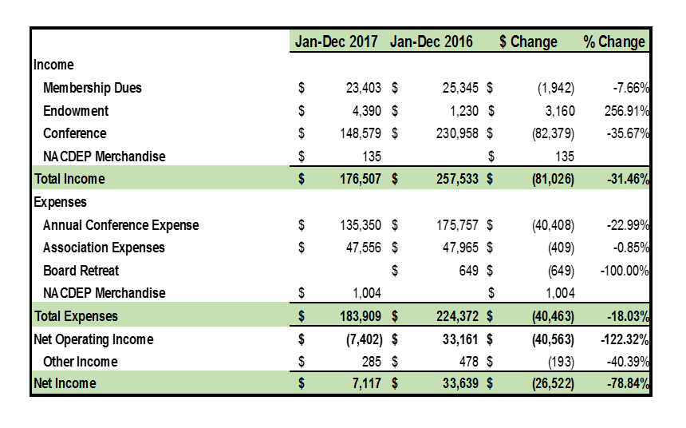

NACDEP’s End-of-year Balance Sheet
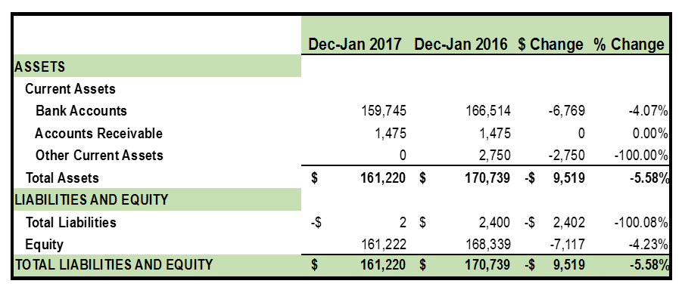

Committee Reports: President Trudy Rice reported that the board met in Cleveland last September for some strategic planning and decided on 4 priority issues: Communication Strategy, Member Engagement, Financial Stability, and Committee/Board Structure and Function. Committee reports will be making reference to these 4 priorities.

Propositional Value Statement: President Trudy Rice shared that JCEP had challenged each association to have a “Propositional Value Statement.” In other words, “What is the value of being a NACDEP member?” Trudy’s proposal was presented. It has been seen, but not yet approved by the board.
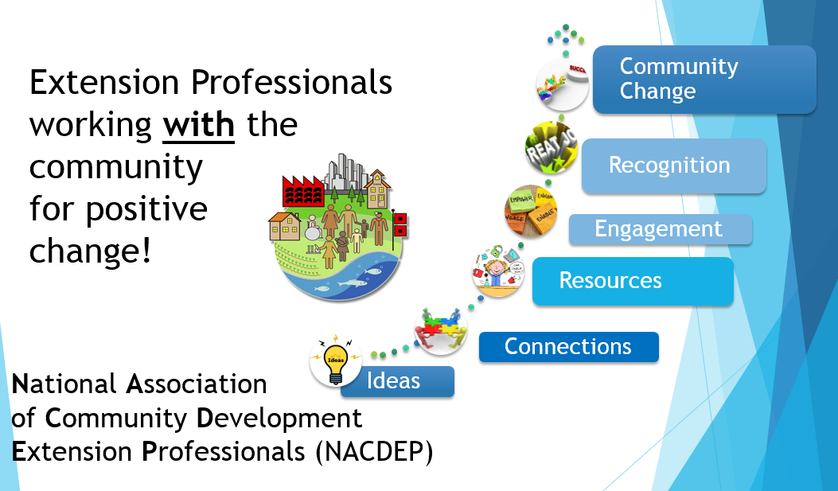

Communications Committee Melinda Grismer

Mission: to facilitate all the communications of NACDEP. Reminder that they will host the “unconference conference” on Tuesday morning at 8am.

Committee Members:
Melinda Grismer, Chairperson
Marie Hvidsten
Jaime Menon
Paul Lachapelle
Dean Larkin
Michael Dougherty
Mark Peterson
Becky Nesbitt
Liaisons to Committee: Dave Shideler, David Civittolo, Richard Proffer
Board Liaison – Brian Raison

Committee Outcomes:
Priority #1 Communication Strategy
- Videographers at the 2018 conference to help us tell our story
Priority #2 Member Engagement
- “Instigating networking” during the conference
Priority #3 Financial Stability
- Negotiated a low cost for the video footage by engaging students from Cleveland
Priority #4 Committee Board Structure/Function
- Discussed a merger with Marketing Committee

Development Committee Stacey McCullough and Michael Wilcox (Co-chairs)
Stacey thanked everyone for the silent auction items and noted that the auction will close prior to the awards banquet on Tuesday evening. Funds help provide registration scholarships.

- Mission: Develop strategies for raising funds with the primary goal of advancing the Association through an endowment for sustainability, sponsorships for visibility and connectivity, and providing scholarships for accessibility.
- Why give to the NACDEP Endowment?
  - Support the mission of NACDE
  - Create a sustainable means of supporting scholarships.
  - Honor of a co-worker, friend, family member, or colleague.
  - As the Endowment grows, NACDEP’s capacity to support targeted efforts such as awards, professional development, and marketing in perpetuity to provide assistance year after year.
- Donate at http://www.nacdep.net/donate
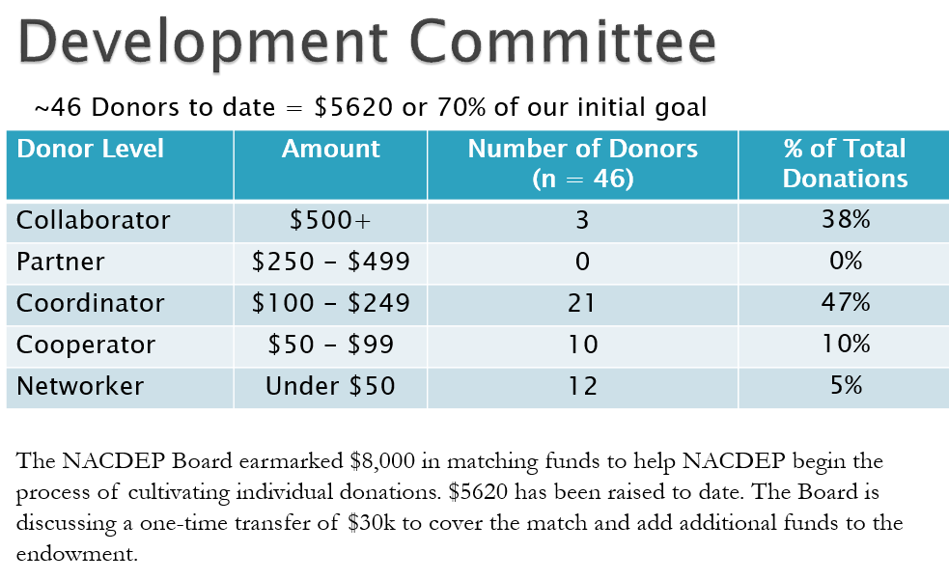

Extension Leadership Conference Sponsored by JCEP Trudy Rice
Addressing the priority of Membership Engagement.
- The 2018 conference was held in Orlando Florida with 12 NACDEP members attending. There was a joint associational meeting with ANREP and an “Edutainment” experience with ANREP (Kayaking trip to learn about environmental issues.)
- The 2019 conference will be in February in San Antonio, Texas. The theme is Cultivating Leadership. Watch for a call for posters and break out session proposals.

Finance Committee Daniel Eades
Committee Members
Daniel Eades, Incoming Chair
Steve Burr, Chair
Nancy Bowen-Ellzey, Board Liaison
Notie Lansford
Greg Davis
Jane Haskell
Eric Romich
Wayne Miller

- Develop Annual Budget
  - Supporting goals and objectives of NACDEP
  - FY 2018 Budget submitted to NACDEP Treasurer and Board on February 23, 2018.
- Conduct Informal Random Audit Annually – 2017 report submitted to board on February 23, 2018
- Review Formal Audit
    - External CPA audit conducted every three years.
    - Complete examination of financial transactions and procedures.
    - Verify procedures and/or guide establishment of revised or new financial practices or procedures.
    - Advise NACDEP President, Treasurer, and Board
  - Complete other tasks related to NACDEP’s financial integrity and/or growth.
- Priority #3 Financial Stability
  - Facilitated the transfer of $36,219 to the NACDEP Endowment Fund
    - Developed motion for Board consideration to hold $125k (2.5 times the operating budget) for reserve, with the balance left moved to the Endowment Fund. Motion approved by Board on February 23, 2018.
  - Working to develop a broader and relevant Financial Vision for NACDEP
    - Working with Endowment Committee to develop a NACDEP Investment Policy for the Endowment Fund for Board consideration.

Journal of Extension Julie Fox
Julie Fox currently serves on the Extension Journal, Inc. board. Previous representative was Mary Emery. Under Priority #2 Member Engagement, Julie reported that 15 NACDEP members had been JOE authors in the last 2 years. JOE is committed to helping new authors. JOE has a display at NACDEP 2018.

Marketing Committee Jamie-Rae Walker Committee Members
Dave Shideler (Chair)
Michael Darger
Christopher Cotton
Rebekka Dudensing
Richard Proffer
Kenneth Sherin
John Turack
Jamie Rae Walker
Suzette Barta, Board Liaison

- Identify opportunities to increase members’ and other extension professionals’ engagement with NACDEP and to maintain and grow membership.
- Research and report to the board on strategic issues, including recruitment and retention of members, target markets, services or products, and related issues.
- Communicate regularly with the communication, development, and member services committees.
- Priority #4 Committee and Board Structure – The Marketing Committee believes they have accomplished the goals the committee was created to do. They recommend that the committee dissolve or have their purpose revised.

Member Services Committee Peggy Schlechter Committee Members
Peggy Schlechter, Chair
Amanda Philyaw-Perez
Deborah Tootle
Paul Thares
John Phillips, Board Liaison
Kelly Nix, Board Liaison

Reporting under Priority #2 Member Engagement, Peggy Schlechter noted that there would be a committee meeting Tuesday morning at 7am, and that new members were encouraged. She also reminded that luggage tags were still available for $5. Sales will fund scholarships. Preference in scholarships is given to those with greater involvement in NACDEP. The committee also hosted the New Member Reception.

Scholarship Recipients:
Jaime Menon, Kansas State University
Meghan Thoreau, Ohio State University
Nancy K Daniels, Kansas State University
Priyanka Brunese, Purdue University
Norman A Schwertfeger, West Virginia

PILD Rebecca Sero
Senior Rep – Rebecca Sero
Junior Rep – Rachel Welborn

Reporting under Priority #2 Member Engagement
- 2018 PILD Conference was sponsored by JCEP. 14 NACDEP members attended.
- 2019 PILD Conference sponsored by JCEP will be held April 14-17, 2019 in Arlington, VA

Recognition Committee Michael Dougherty
Committee Members
Michael Dougherty, Chair
Cheryl Burkhart-Kriesel
Daniel Eades
Katie Hoffman
Susan Jakes
Rachel Welborn
Carroll Welte
Susan Kelly, Board Liaison

Reporting under Priority #2 Member Engagement, Michael Dougherty explained their role is to, “Make your outstanding work known to those in this room, your state, and beyond.”

The committee honors the efforts of NACDEP members through the annual awards process. The awards are designed to engage the membership. The committee communicates with the membership about the awards and their importance throughout the year. The committee receives the applications, oversees their review, and hold the awards ceremony at the NACDEP conference. Awards will be given at the awards banquet on Tuesday evening. The awards program is on the Guidebook app.

They will have a committee meeting Tuesday morning at 7am. New members are welcome.

Regional Reports Brian Raison
Regional Representatives
Western Laura Ryser – 33 members
Northeast Mary Peabody – 26 members
North Central Brian Raison – 186 members
Southern Susan Kelly – 49 members
John Phillips – 1994 Rep
Adam Hodges – 1890 Rep

Priority #1 Communication Strategy
- Regional Newsletters
- Email updates
- Involvement in hosting NACDEP Annual conference
- Google map of members
Priority #2 Member Engagement
- Quarterly Zoom updates
- Cross state collaboration to create synergy among CD efforts
- Encourage member renewal
- Recruit members for committees
- Regional Meetings – today at 4:15-5pm – Regional awards will be given.
  - Southern – Whitehall
  - Western – Blossom Room
  - NC – Gold Ballroom
  - NE – Hopkins
- Discussion Questions
  - What do you see as NACDEP’s Value Proposition?
  - How can NACDEP improve its value proposition?
  - Is NACDEP meeting your needs?
  - What else could NACDEP do as a professional association?
  - How can we improve NACDEP?

ByLaw Changes Kelly Nix

In section 1. Membership. Active members must be 25% or more Extension appointment. Affiliate members are not employed by Extension. So, what does that mean for a person with a 10% Extension appointment?

Proposed change: Affiliate members either have less than a 25% Extension appointment or are not employed by Cooperative Extension Service but in either case have an interest in community development education, outreach, or research.
Special note: this aligns with JCEP

Motion made to accept this change made by Michael Dougherty. Notie Lansford seconded. Motion carried.

NACDEP’s Management Firm
NACDEP president, Trudy Rice recognized Ricky and Jody Atkins from NACDEP’s management firm, The Association Source (TAS). She encouraged members use Member Clicks on the NACDEP website, www.nacdep.net

Recognition of New Board
NACDEP president, Trudy Rice recognized members of the new NACDEP Board and handed over the gavel to the new President David Civittolo. The 2018-19 NACDEP Board is comprised of:
- President: David Civittolo
- President-Elect: Susan Kelly
- Past President: Trudy Rice
- Treasurer: Nancy Bowen Ellzey
- Secretary: Michael Dougherty
- South Rep: Amanda Philyaw-Perez
- Northeast: Mary Peabody
- North Central: Brian Baison
- West: Laura Reyser
- 1890: Adam Hodges
- 1994: Yvonedda “Henry” Thompson

David Civittolo thanked outgoing Board Members:
- Kelly Nix – Past President
- Suzette Barta - Secretary
- Susan Kelly – Southern Rep
- John Phillips – 1994 Rep

David Civittolo presented a plaque thanking Trudy Rice for her leadership as President of NACDEP 2017-18.

2019 Conference – Asheville, North Carolina - June 9 thru 12
Susan Kelly – North Carolina State University

2020 Conference – Portsmouth, New Hampshire, May 31- June 3
Mary Peabody, NE Rep

Announcements
- Posters manned on Tuesday, 10:30am to noon
- “Unconference conference” Tuesday morning right after committee meetings
- Guidebook app information presented by Eric Romich. He noted that we are at 75% adoption of Guidebook.
Motion to adjourn by Allison Davis.
Second by Mary Peabody
Meeting was adjourned by David Civittolo at 2:06pm.

