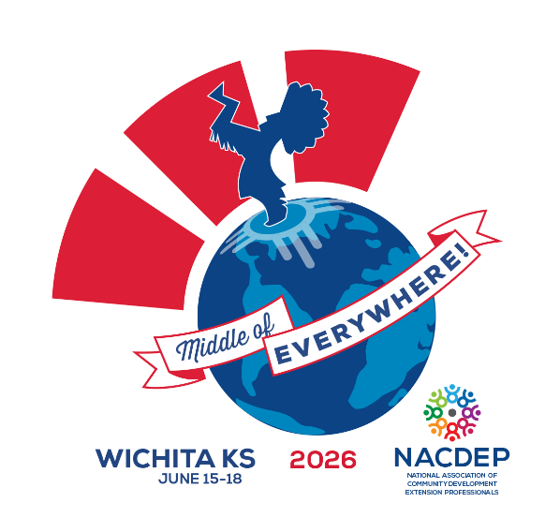

Sunday, June 14 – Set Up Day
Monday, June 15 – Day 0 - Registration and Gathering (Travel) Day
9-4 Pre-Conference Workshops (All Day or Half Day)
12-1 NACDEP Board Meeting
1-4 Program Leader’s Meeting
4 - 5:30 Land Use Planning Committee of Practice (NACDEP Working Group)
4:15-5:30 Newcomer’s Session/Orientation
6:15 – Welcome Event – Drury Hotel
6:30-8 Welcome Reception/Opening Plenary- Drury Hotel
- Dr. Gregg Hadley
- Mayor Lily Wu
8 - Dinner on your own
Tuesday, June 16 – Day 1 of Conference
6-8 Breakfast
7-8 Morning “Wake UP” activity
8-9 Plenary Session
- 8am - Cowboy Poem by Ron Wilson
- 8-8:45am - Keynote Dr. Marshall Stewart
9-10:30 Concurrent Session 1
10:45-12:15 Concurrent Session 2
12:15-1:45 Lunch and Business Meeting
2:00- 3:30 Concurrent Session 3
3:30-4:30 Regional Meetings
4:30-5:30 1890 & 1994 Meetings
Dinner on your own (State’s Night Out)
Wednesday, June 17 – Day 2 - Mobile Workshop Day
6-8 Breakfast
7-8 Morning “Wake UP” activity
8-9:30 Plenary Session
9:45 – 11:15 Concurrent Session 4
11:30-12:30 Lunch
12:30-5:00 Mobile Learning Workshops
6:00-7:00 Reception and Poster Session
7:00-8:30 Awards Banquet
8:30-10:00 Entertainment
Thursday, June 18 – Day 3 – Wrap Up and Safe Travels
6-8 Breakfast
7-8 Morning “Wake UP” activity
8-9:30 Concurrent Session 5
10:00-11:30 Closing Plenary
- Panel Speakers
11:30-1:30 NACDEP Board Meeting
12:00-5 Post Conference Workshops

